**Institute of Information Technology (IIT)**

Jahangirnagar University



**Lab Report: 06**

Submitted by:

Name: Md. Shakil Hossain  
Roll No: 2023

Lab Date: 22/08/2023  
Submission Date: 29/08/2023

K Nearest Neighbors(K-NN) Import Libraries

In [12]:

**import** pandas **as** pd

**import** numpy **as** np

**import** seaborn **as** sns

**import** matplotlib.pylab **as** plt

**%**matplotlib inline

Get the Data

In [13]:

glass_data **=** pd.read_csv("glass.csv")

In [14]:

glass_data.head()

Out[14]:

|  |  |  |  |  |  |  |  |  |  |
| --- | --- | --- | --- | --- | --- | --- | --- | --- | --- |
| **RI** | **Na** | **Mg** | **Al** | **Si** | **K** | **Ca** | **Ba** | **Fe** | **Type** |
| **0** 1.52101 | 13.64 | 4.49 | 1.10 | 71.78 | 0.06 | 8.75 | 0.0 | 0.0 | 1 |
| **1** 1.51761 | 13.89 | 3.60 | 1.36 | 72.73 | 0.48 | 7.83 | 0.0 | 0.0 | 1 |
| **2** 1.51618 | 13.53 | 3.55 | 1.54 | 72.99 | 0.39 | 7.78 | 0.0 | 0.0 | 1 |
| **3** 1.51766 | 13.21 | 3.69 | 1.29 | 72.61 | 0.57 | 8.22 | 0.0 | 0.0 | 1 |
| **4** 1.51742 | 13.27 | 3.62 | 1.24 | 73.08 | 0.55 | 8.07 | 0.0 | 0.0 | 1 |

In [15]:

glass_data.describe().transpose()

Out[15]:

|  |  |  |  |  |  |  |  |  |
| --- | --- | --- | --- | --- | --- | --- | --- | --- |
|  | **count** | **mean** | **std** | **min** | **25%** | **50%** | **75%** | **max** |
| **RI** | 214.0 | 1.518365 | 0.003037 | 1.51115 | 1.516522 | 1.51768 | 1.519157 | 1.53393 |
| **Na** | 214.0 | 13.407850 | 0.816604 | 10.73000 | 12.907500 | 13.30000 | 13.825000 | 17.38000 |
| **Mg** | 214.0 | 2.684533 | 1.442408 | 0.00000 | 2.115000 | 3.48000 | 3.600000 | 4.49000 |
| **Al** | 214.0 | 1.444907 | 0.499270 | 0.29000 | 1.190000 | 1.36000 | 1.630000 | 3.50000 |
| **Si** | 214.0 | 72.650935 | 0.774546 | 69.81000 | 72.280000 | 72.79000 | 73.087500 | 75.41000 |
| **K** | 214.0 | 0.497056 | 0.652192 | 0.00000 | 0.122500 | 0.55500 | 0.610000 | 6.21000 |
| **Ca** | 214.0 | 8.956963 | 1.423153 | 5.43000 | 8.240000 | 8.60000 | 9.172500 | 16.19000 |
| **Ba** | 214.0 | 0.175047 | 0.497219 | 0.00000 | 0.000000 | 0.00000 | 0.000000 | 3.15000 |
| **Fe** | 214.0 | 0.057009 | 0.097439 | 0.00000 | 0.000000 | 0.00000 | 0.100000 | 0.51000 |
| **Type** | 214.0 | 2.780374 | 2.103739 | 1.00000 | 1.000000 | 2.00000 | 3.000000 | 7.00000 |

In [16]:

glass_data.info()

<class 'pandas.core.frame.DataFrame'> RangeIndex: 214 entries, 0 to 213

Data columns (total 10 columns):

# Column Non-Null Count Dtype

|  |  |  |  |  |  |  |  |
| --- | --- | --- | --- | --- | --- | --- | --- |
| 0 |  | RI |  | 214 | non-null |  | float64 |
| 1 |  | Na |  | 214 | non-null |  | float64 |
| 2 |  | Mg |  | 214 | non-null |  | float64 |
| 3 |  | Al |  | 214 | non-null |  | float64 |
| 4 |  | Si |  | 214 | non-null |  | float64 |
| 5 |  | K |  | 214 | non-null |  | float64 |
| 6 |  | Ca |  | 214 | non-null |  | float64 |
| 7 |  | Ba |  | 214 | non-null |  | float64 |
| 8 |  | Fe |  | 214 | non-null |  | float64 |
| 9 |  | Type |  | 214 | non-null |  | int64 |

dtypes: float64(9), int64(1) memory usage: 16.8 KB

In [17]:

glass_data.isnull().sum()

Out[17]:

|  |  |
| --- | --- |
| RI | 0 |
| Na | 0 |
| Mg | 0 |
| Al | 0 |
| Si | 0 |
| K | 0 |
| Ca | 0 |
| Ba | 0 |
| Fe | 0 |
| Type | 0 |
| dtype: | int64 |

In [18]:

glass_data.hist(figsize**=**(20,20))

Out[18]:

array([[<Axes: title={'center': 'RI'}>, <Axes: title={'center': 'Na'}>,

<Axes: title={'center': 'Mg'}>],

[<Axes: title={'center': 'Al'}>, <Axes: title={'center': 'Si'}>,

<Axes: title={'center': 'K'}>],

[<Axes: title={'center': 'Ca'}>, <Axes: title={'center': 'Ba'}>,

<Axes: title={'center': 'Fe'}>],

[<Axes: title={'center': 'Type'}>, <Axes: >, <Axes: >]], dtype=object)

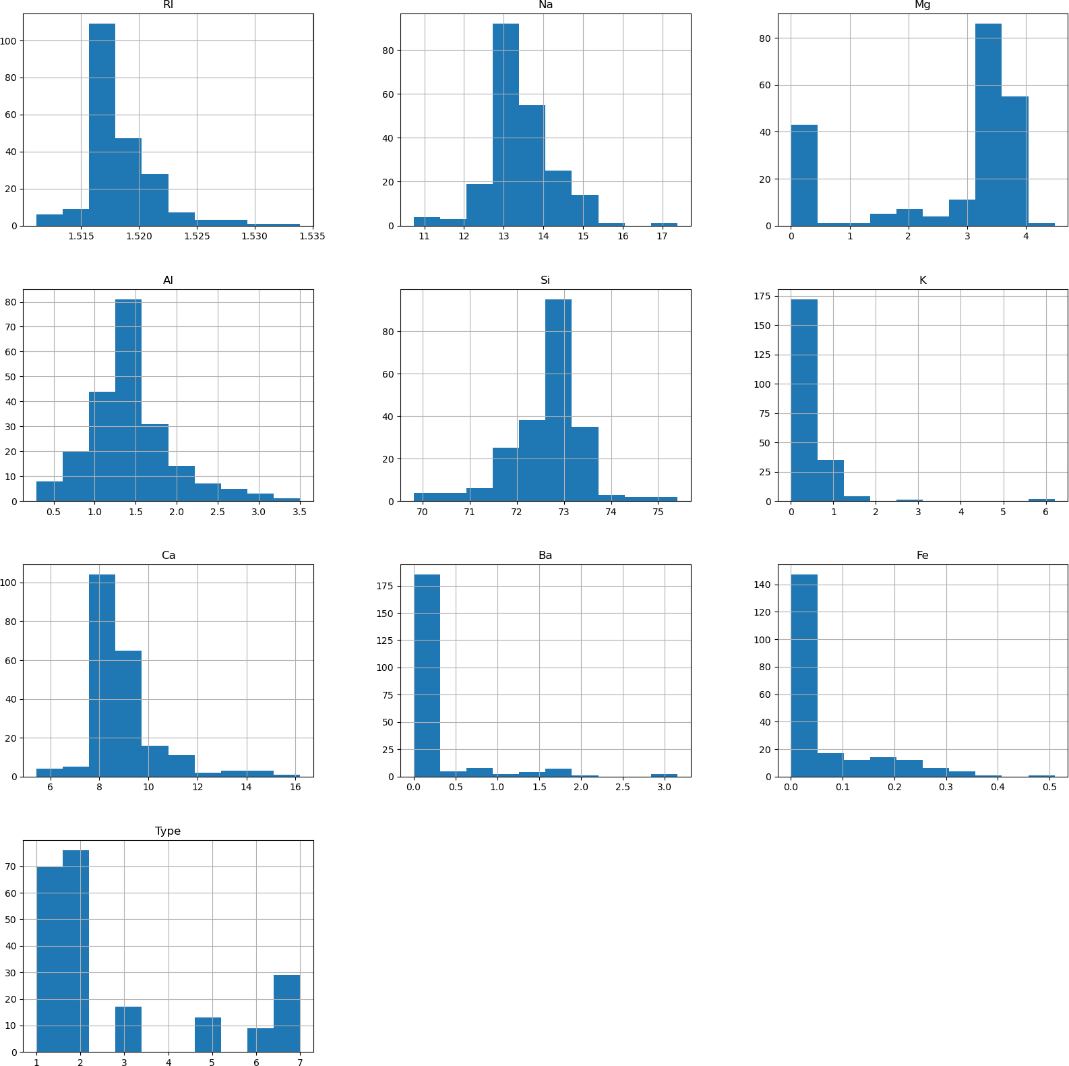

In [19]:

sns.pairplot(glass_data, hue**=**'Type')

Out[19]:

<seaborn.axisgrid.PairGrid at 0x170e0cdc580>

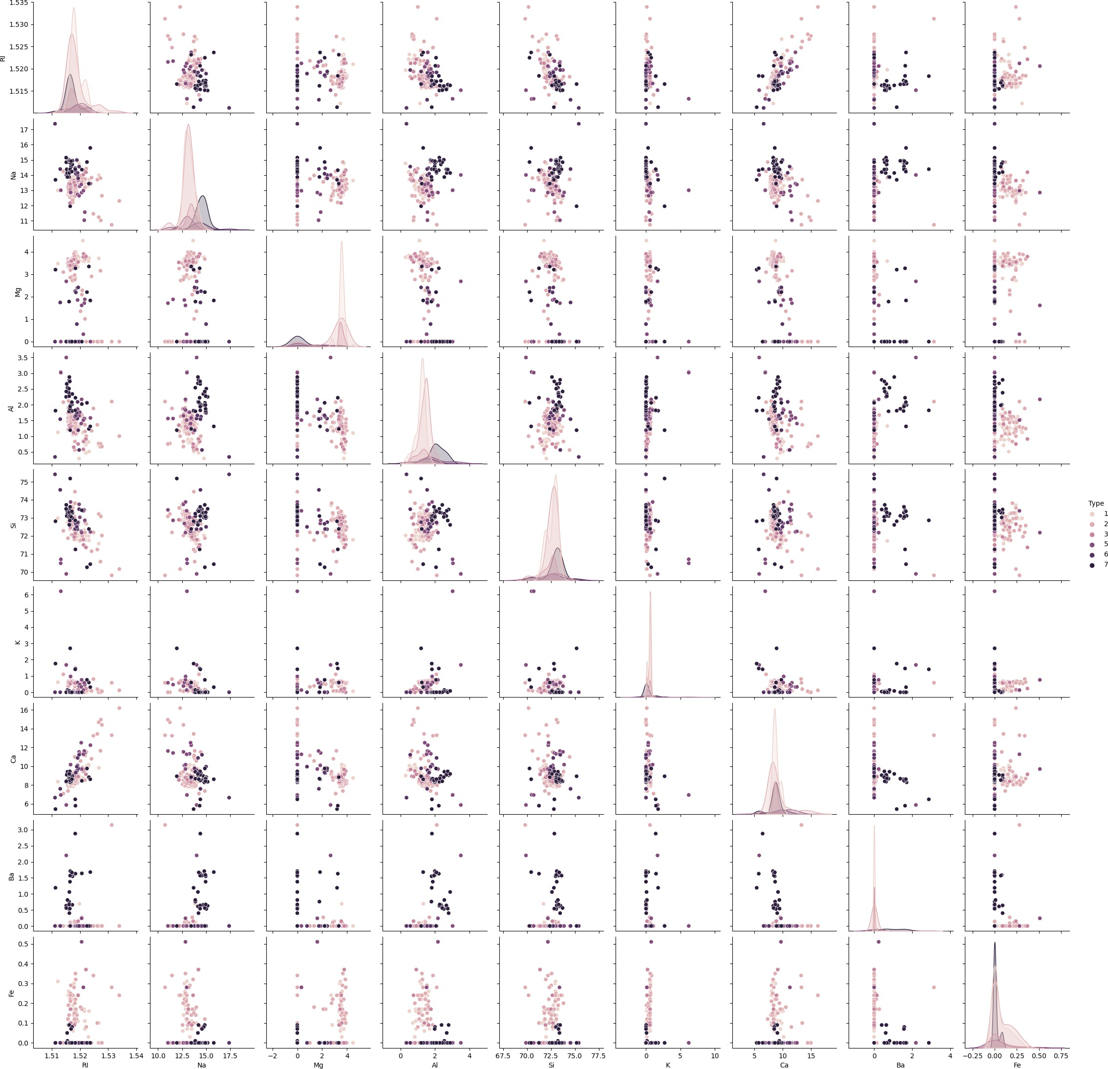

standardize the variables

In [20]:

**from** sklearn.preprocessing **import** StandardScaler

In [21]:

scaler **=** StandardScaler()

In [22]:

X **=** pd.DataFrame(scaler.fit_transform(glass_data.drop(["Type"],axis **=** 1))) y **=** glass_data.Type

|  |  |  |  |  |  |  |  |  |
| --- | --- | --- | --- | --- | --- | --- | --- | --- |
| In [23]: |  | | | | | | | |
| X.head() |  |  |  |  |  |  |  |  |
| Out[23]: |  |  |  |  |  |  |  |  |
| **0** | **1** | **2** | **3** | **4** | **5** | **6** | **7** |  |
| **0** 0.872868 | 0.284953 | 1.254639 | -0.692442 | -1.127082 | -0.671705 | -0.145766 | -0.352877 | -0.5 |
| **1** -0.249333 | 0.591817 | 0.636168 | -0.170460 | 0.102319 | -0.026213 | -0.793734 | -0.352877 | -0.5 |
| **2** -0.721318 | 0.149933 | 0.601422 | 0.190912 | 0.438787 | -0.164533 | -0.828949 | -0.352877 | -0.5 |
| **3** -0.232831 | -0.242853 | 0.698710 | -0.310994 | -0.052974 | 0.112107 | -0.519052 | -0.352877 | -0.5 |
| **4** -0.312045 | -0.169205 | 0.650066 | -0.411375 | 0.555256 | 0.081369 | -0.624699 | -0.352877 | -0.5 |

Train Test Split

In [24]:

**from** sklearn.model_selection **import** train_test_split

In [25]:

X_train, X_test, y_train, y_test **=** train_test_split(X,y,test_size**=**0.30)

Using KNN

In [26]:

**from** sklearn.neighbors **import** KNeighborsClassifier

In [27]:

knn **=** KNeighborsClassifier(n_neighbors**=**1)

In [28]:

knn.fit(X_train,y_train)

Out[28]:

▾

KNeighborsClassifier

KNeighborsClassifier(n_neighbors=1)

In [29]:

pred **=** knn.predict(X_test)

Predictions and Evaluations

In [30]:

**from** sklearn.metrics **import** classification_report,confusion_matrix

In [31]:

print(confusion_matrix(y_test,pred))

|  |  |  |  |  |  |
| --- | --- | --- | --- | --- | --- |
| [[20 | 3 | 1 | 0 | 0 | 0] |
| [ 5 | 20 | 2 | 2 | 0 | 0] |
| [ 3 | 0 | 1 | 0 | 0 | 0] |
| [ 0 | 0 | 0 | 3 | 0 | 0] |
| [ 0 | 0 | 0 | 0 | 1 | 0] |
| [ 0 | 0 | 0 | 0 | 0 | 4]] |

In [32]:

print(classification_report(y_test,pred))

|  |  |  |  |  |
| --- | --- | --- | --- | --- |
|  | precision | recall | f1-score | support |
| 1 | 0.71 | 0.83 | 0.77 | 24 |
| 2 | 0.87 | 0.69 | 0.77 | 29 |
| 3 | 0.25 | 0.25 | 0.25 | 4 |
| 5 | 0.60 | 1.00 | 0.75 | 3 |
| 6 | 1.00 | 1.00 | 1.00 | 1 |
| 7 | 1.00 | 1.00 | 1.00 | 4 |
| accuracy |  |  | 0.75 | 65 |
| macro avg | 0.74 | 0.80 | 0.76 | 65 |
| weighted avg | 0.77 | 0.75 | 0.75 | 65 |

Choosing a K Value

In [33]:

error_rate **=** []

*# Will take some time*

**for** i **in** range(1,40):

knn **=** KNeighborsClassifier(n_neighbors**=**i) knn.fit(X_train,y_train)

pred_i **=** knn.predict(X_test)

error_rate.append(np.mean(pred_i **!=** y_test))

In [34]:

plt.figure(figsize**=**(10,6))

plt.plot(range(1,40),error_rate,color**=**'blue', linestyle**=**'dashed', marker**=**'o', markerfacecolor**=**'red', markersize**=**10)

plt.title('Error Rate vs. K Value') plt.xlabel('K')

plt.ylabel('Error Rate')

Out[34]:

Text(0, 0.5, 'Error Rate')

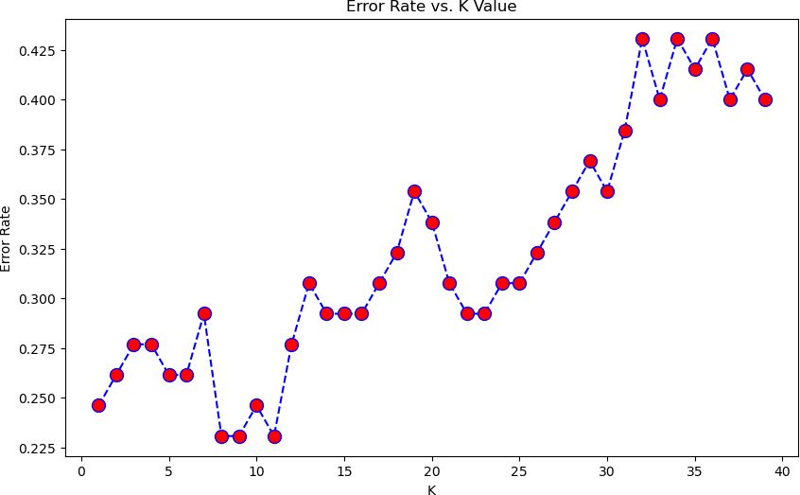

In [35]:

*#Orginal K=1*

knn **=** KNeighborsClassifier(n_neighbors**=**1)

knn.fit(X_train,y_train)

pred **=** knn.predict(X_test)

print('WITH k=1') print('\n')

print(confusion_matrix(y_test,pred)) print('\n')

print(classification_report(y_test,pred))

|  |  |  |  |  |  |
| --- | --- | --- | --- | --- | --- |
| WITH | k=1 |  | | | |
| [[20 | 3 | 1 | 0 | 0 | 0] |
| [ 5 | 20 | 2 | 2 | 0 | 0] |
| [ 3 | 0 | 1 | 0 | 0 | 0] |
| [ 0 | 0 | 0 | 3 | 0 | 0] |
| [ 0 | 0 | 0 | 0 | 1 | 0] |
| [ 0 | 0 | 0 | 0 | 0 | 4]] |

|  |  |  |  |  |
| --- | --- | --- | --- | --- |
|  | precision | recall | f1-score | support |
| 1 | 0.71 | 0.83 | 0.77 | 24 |
| 2 | 0.87 | 0.69 | 0.77 | 29 |
| 3 | 0.25 | 0.25 | 0.25 | 4 |
| 5 | 0.60 | 1.00 | 0.75 | 3 |
| 6 | 1.00 | 1.00 | 1.00 | 1 |
| 7 | 1.00 | 1.00 | 1.00 | 4 |
| accuracy |  |  | 0.75 | 65 |
| macro avg | 0.74 | 0.80 | 0.76 | 65 |
| weighted avg | 0.77 | 0.75 | 0.75 | 65 |

In [36]

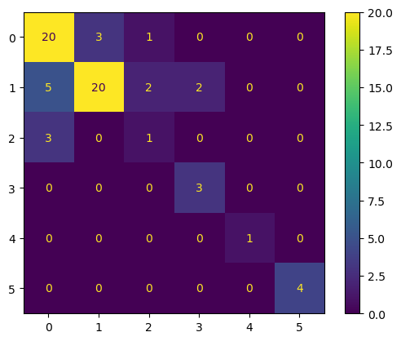

**from** sklearn.metrics **import** ConfusionMatrixDisplay

**import** matplotlib.pyplot **as** plt

conf_matrix **=** confusion_matrix(y_test, pred)

vis **=** ConfusionMatrixDisplay(confusion_matrix **=** conf_matrix,display_labels **=** [**True**,**False** vis.plot()

plt.grid(**False**) plt.show()

*#Now With K=17*

In [37]:

knn **=** KNeighborsClassifier(n_neighbors**=**17)

knn.fit(X_train,y_train)

pred **=** knn.predict(X_test)

print('WITH k=17') print('\n')

print(confusion_matrix(y_test,pred)) print('\n')

print(classification_report(y_test,pred))

|  |  |  |  |  |  |
| --- | --- | --- | --- | --- | --- |
| WITH | k=17 |  | | | |
| [[21 | 3 | 0 | 0 | 0 | 0] |
| [ 7 | 20 | 0 | 0 | 2 | 0] |
| [ 4 | 0 | 0 | 0 | 0 | 0] |
| [ 1 | 1 | 0 | 1 | 0 | 0] |
| [ 1 | 0 | 0 | 0 | 0 | 0] |
| [ 0 | 1 | 0 | 0 | 0 | 3]] |



|  |  |  |  |  |
| --- | --- | --- | --- | --- |
|  | precision | recall | f1-score | support |
| 1 | 0.62 | 0.88 | 0.72 | 24 |
| 2 | 0.80 | 0.69 | 0.74 | 29 |
| 3 | 0.00 | 0.00 | 0.00 | 4 |
| 5 | 1.00 | 0.33 | 0.50 | 3 |
| 6 | 0.00 | 0.00 | 0.00 | 1 |
| 7 | 1.00 | 0.75 | 0.86 | 4 |

In [38]:

**from** sklearn.metrics **import** ConfusionMatrixDisplay

**import** matplotlib.pyplot **as** plt

conf_matrix **=** confusion_matrix(y_test, pred)

vis **=** ConfusionMatrixDisplay(confusion_matrix **=** conf_matrix,display_labels **=** [**True**,**False** vis.plot()

plt.grid(**False**) plt.show()

In [ ]:

